1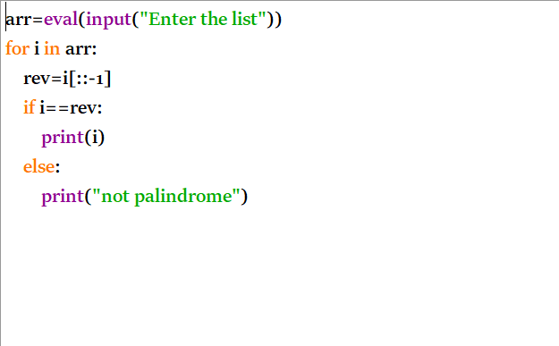
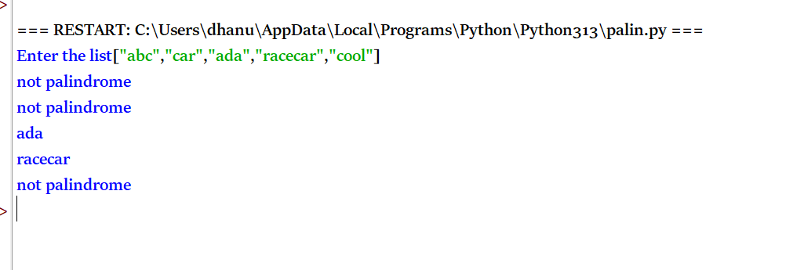
TIME COMPLEXITY: O(n × m)
SPACE COMPLEXITY: O(1)
2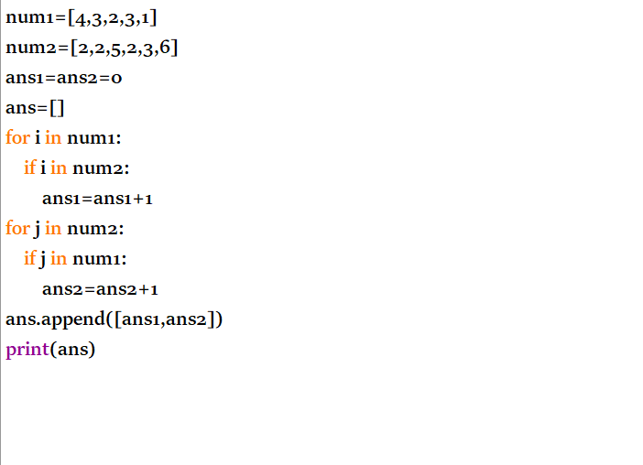
OUTPUT
Time Complexity: O(n × m)
Space Complexity: O(1)
3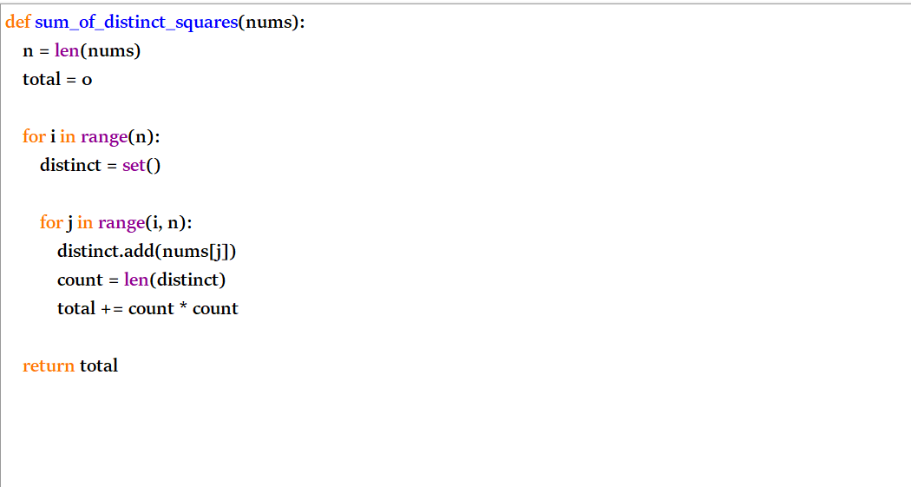
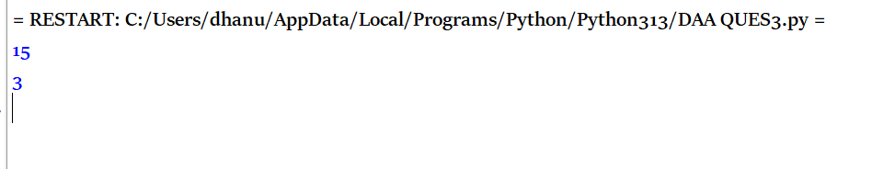
TIME COMPLEXITY: O(n²)
SPACE COMPLEXITY:O(n)
4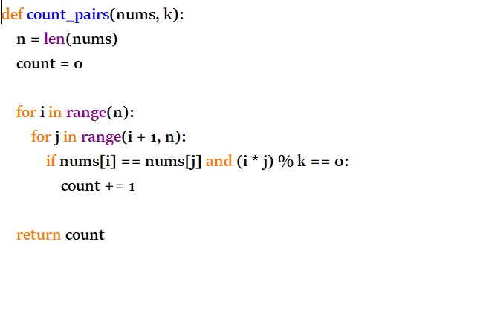
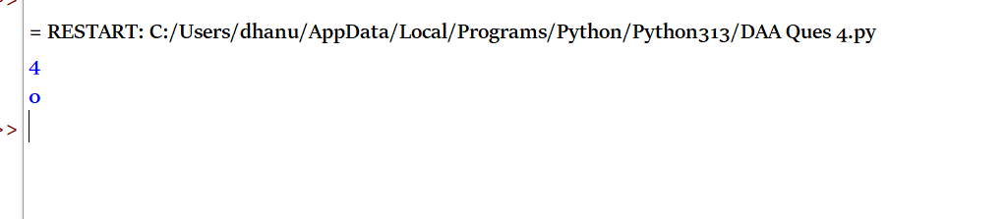
Time Complexity: O(n²)
Space Complexity:O(1)
5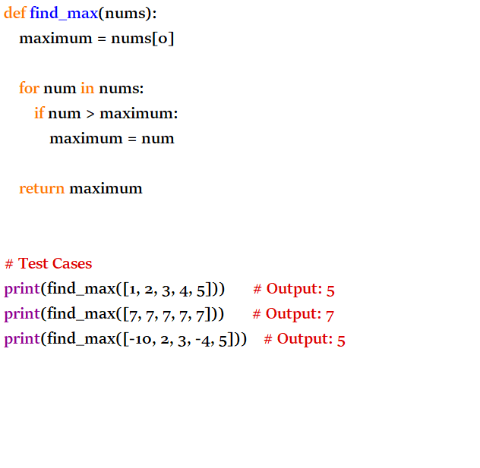
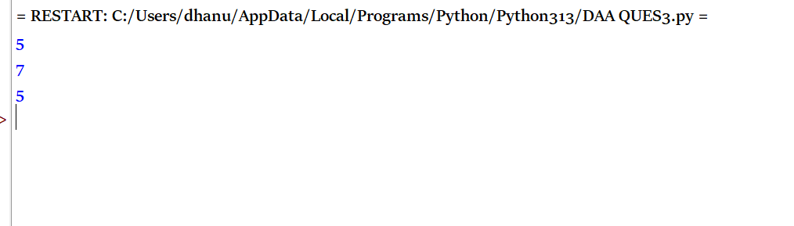
TIME COMPLEXITY:O(n)
SPACE COMPLEXITY:O(1)
6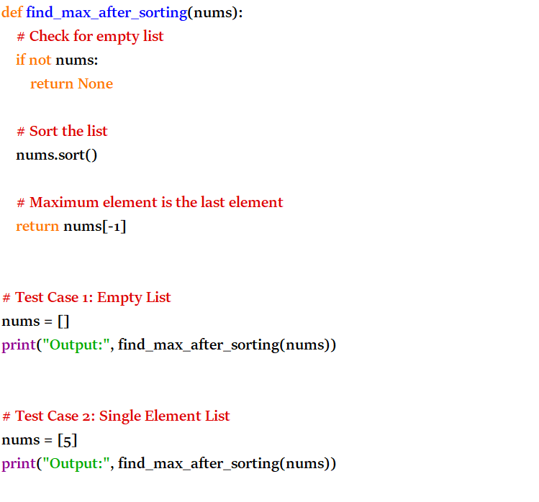
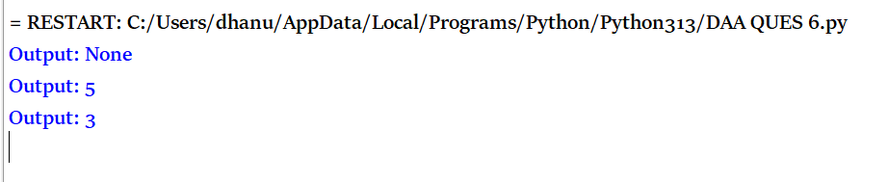
TIME COMPLEXITY: O(n log n)
SPACE COMPLEXITY: O(n)
7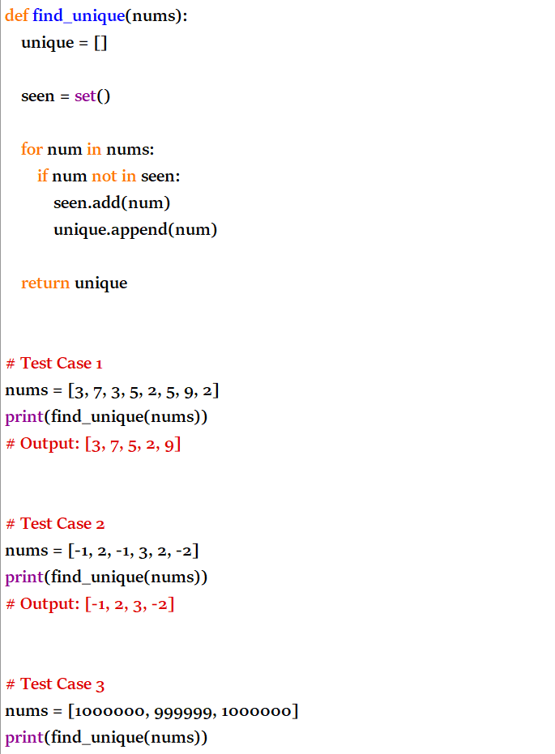
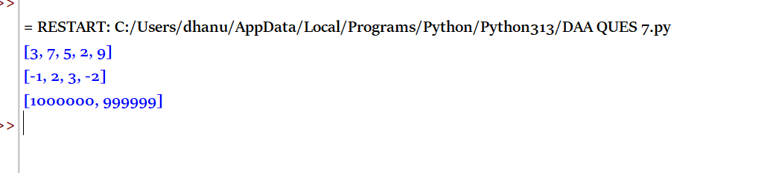
TIME COMPLEXITY: O(n)
SPACE COMPLEXITY: O(n)
8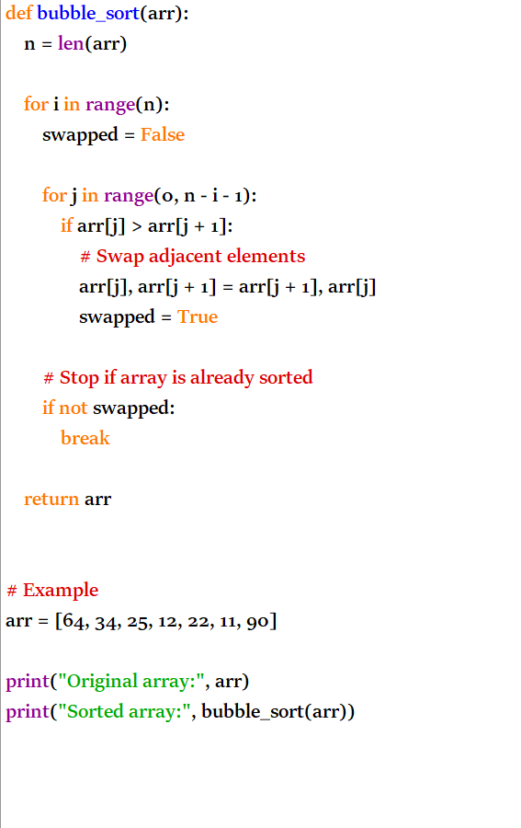
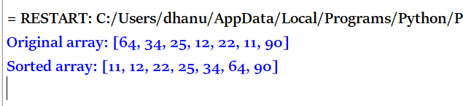
TIME COMPLEXITY: O(n²)
SPACE COMPLEXITY: O(1)
9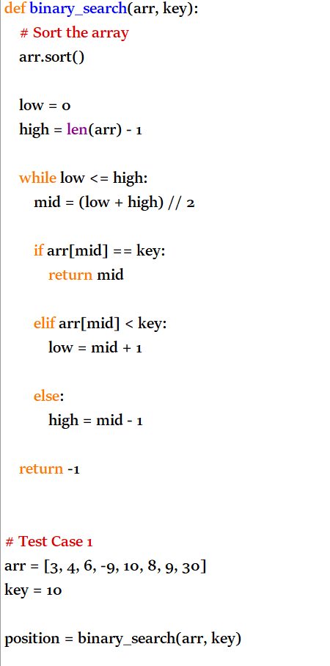
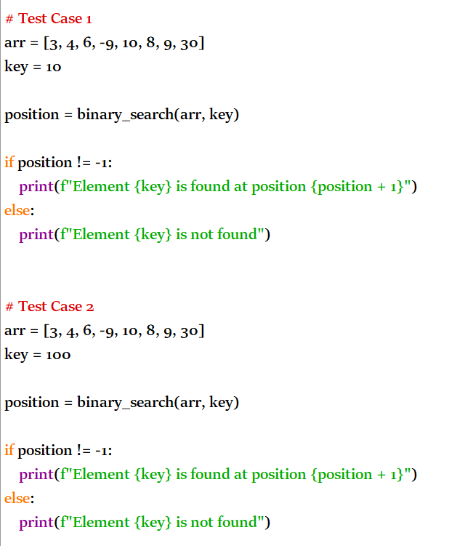
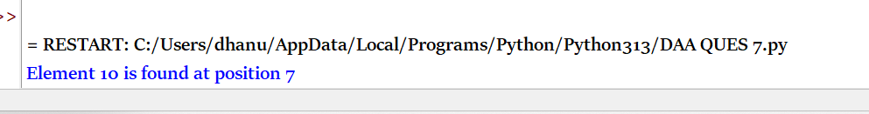
TIME COMPLEXITY: O(n log n)
SPACE COMPLEXITY:O(1)
10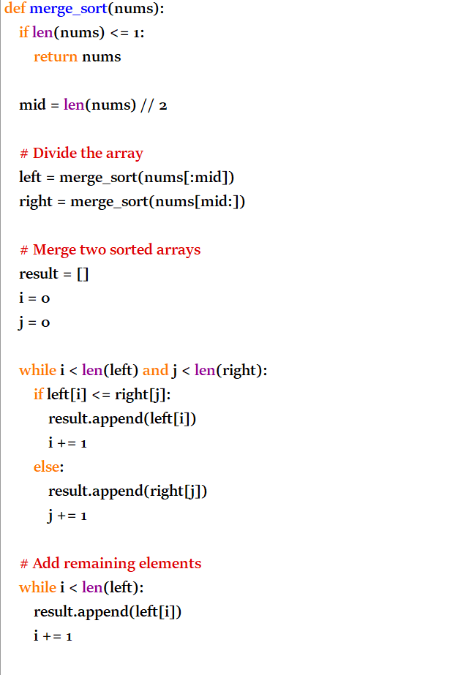
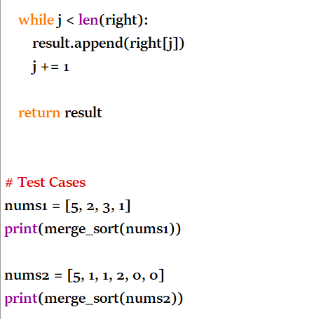
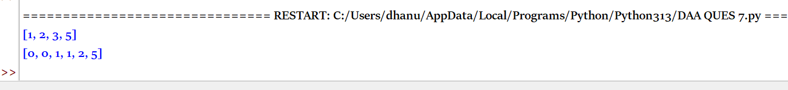

TOPIC 5
1

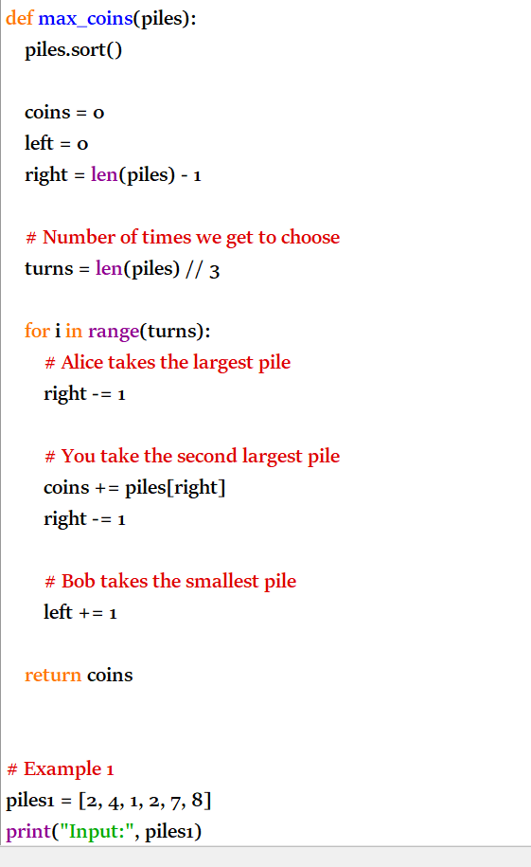

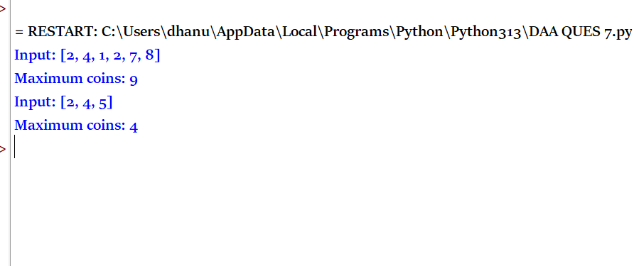
Overall Time Complexity: O(n log n)
Space Complexity: O(1)

2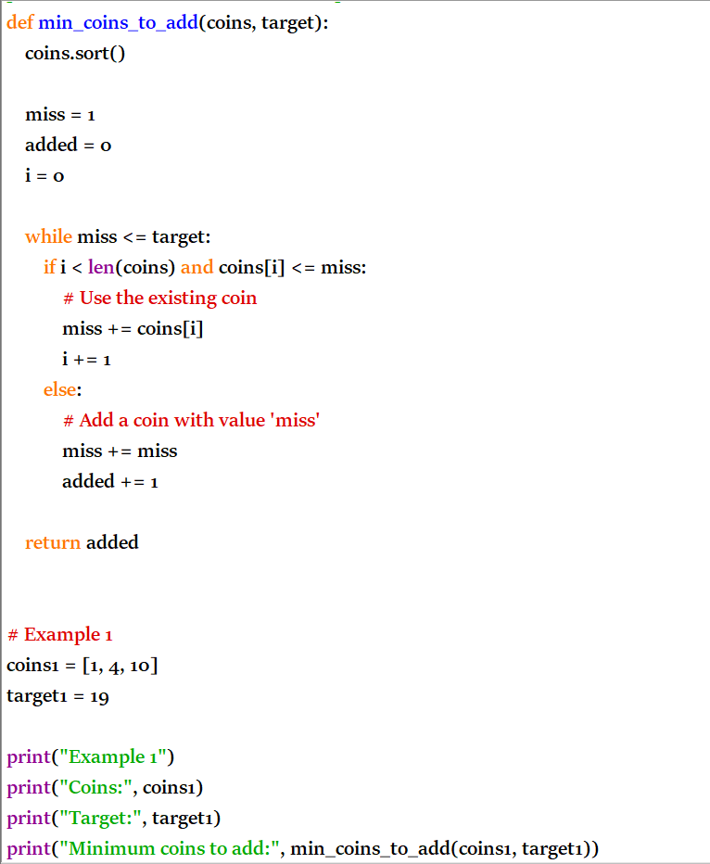
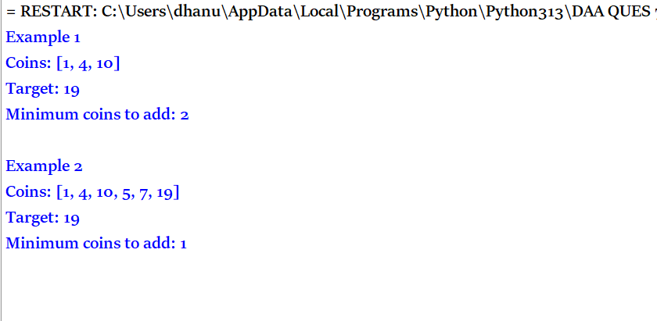
Time complexity: O(n log n)
Space complexity: O(1)
3
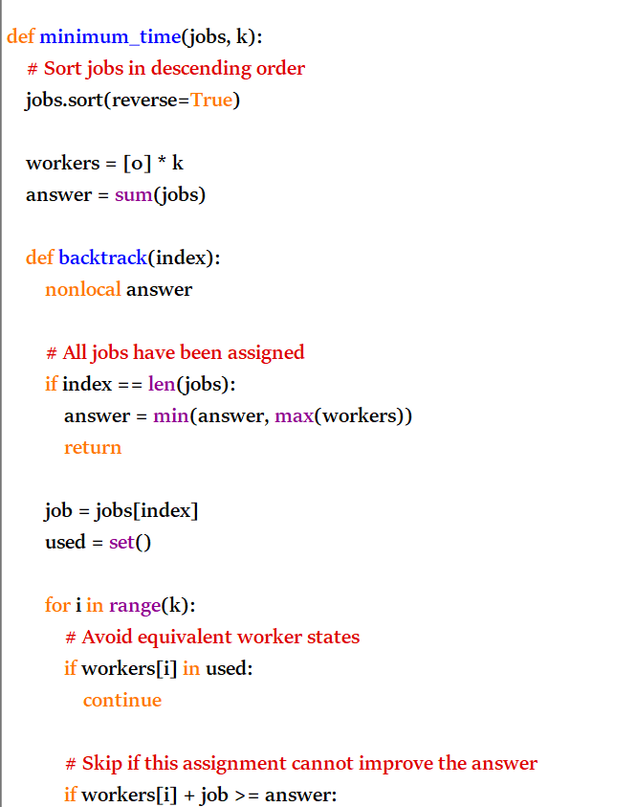
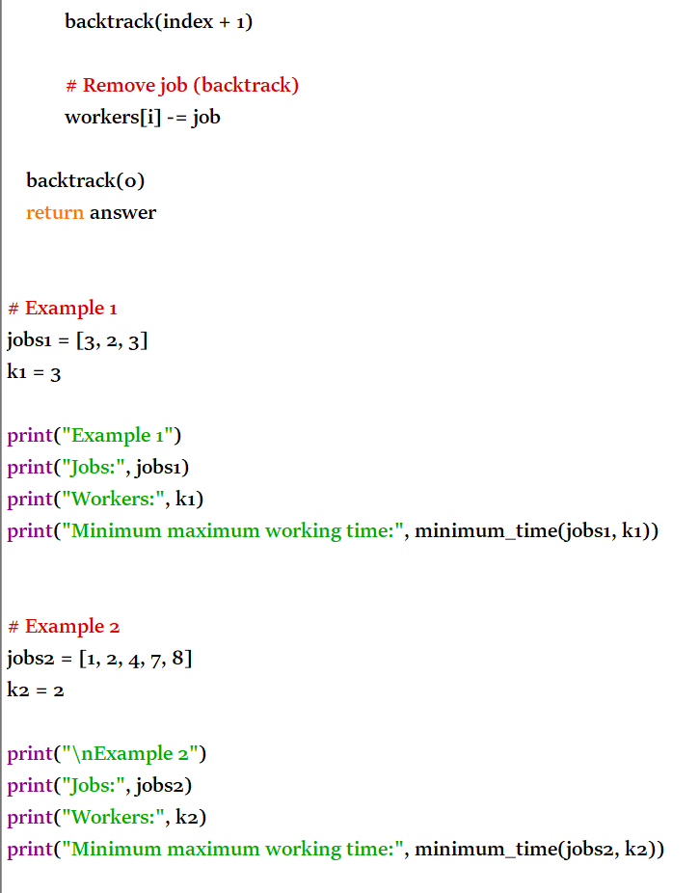
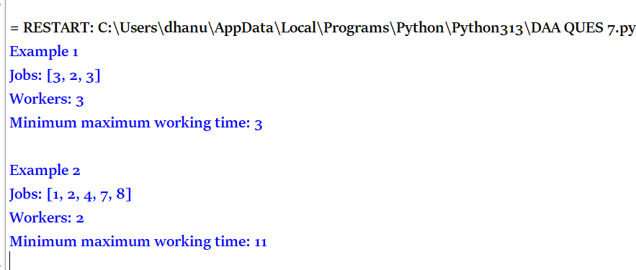
Time Complexity: O(k^n) in the worst case
Space Complexity: O(n + k)

4
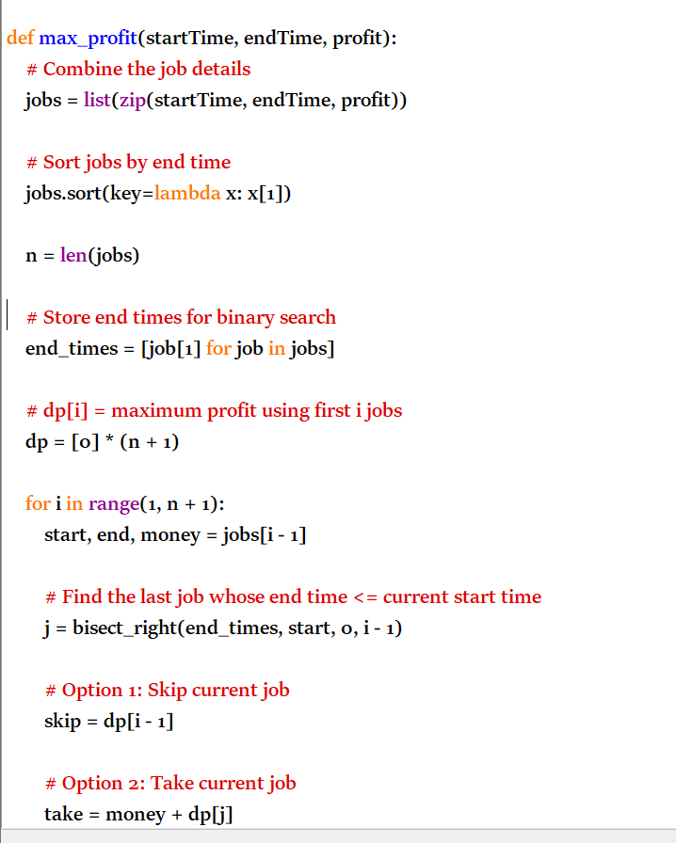
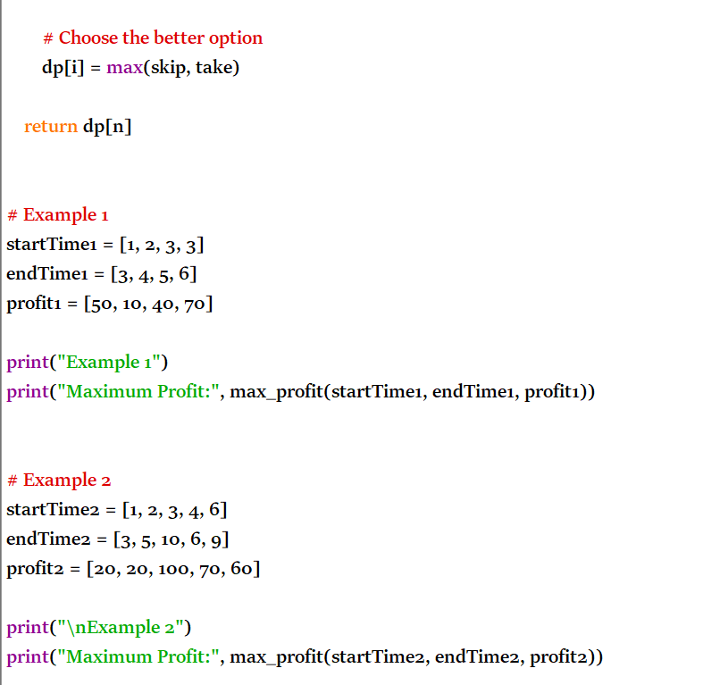
Time Complexity: O(n log n)
Space Complexity: O(n)

